# Island Wars: AR

## NYU AR and VR and 3D Graphics Capstone

Thomas Bales

5/3/22

Short description: Island Wars: AR, is floating island battleship game that pits two players against each other in a duel (*see figure 1*).

Long description: Two floating islands engage each other by navigating an arena filled with obstacles. Additionally, Islands can extract resources for thrust, health, and advancing their tech tree. Islands also fall into categories and can have weapon customization. For the demo there are two classes. A torpedo class and a tesla class. The Environment can help or hurt each island and how a player uses this mechanic to their advantage can determine the outcome of the battle. Phases have been included in this document and the current priority is movement and arena development. Phase 2 will be resource management and weapon interactions.

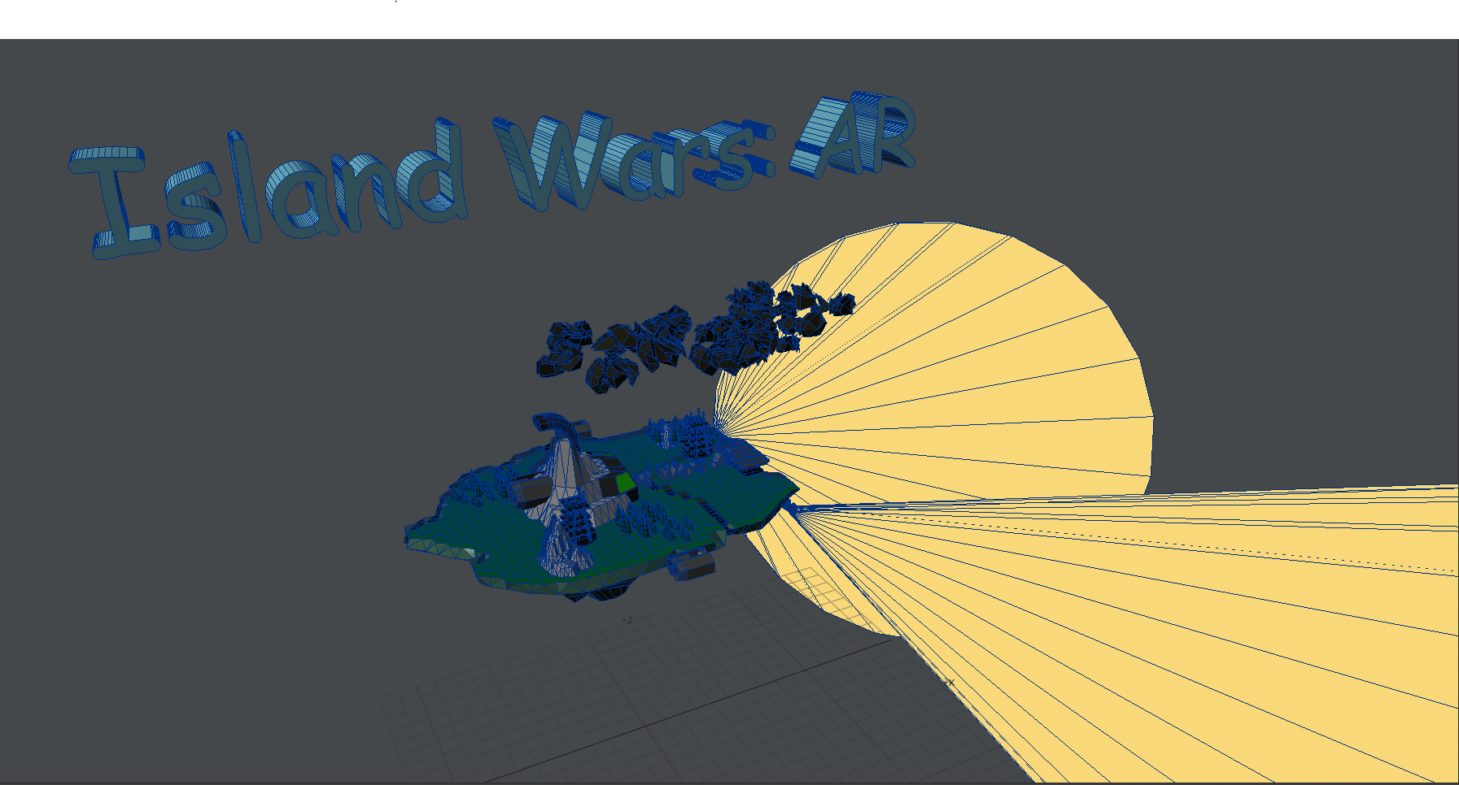

*Figure 1. Main Island Model – Torpedo Class*

## Game Hardware Requirements

As of this time, this game is being developed using NREAL Light glasses. In the future I plan to port this to Magic Leap and to a mobile AR compatible mobile device. However at this time, the Magic Leap development kit is broken when it comes to following API documentations and movement and raycasting controls. Moreover, the device is expensive and likely won’t be release as at a consumer level. Since Magic Leap is targeting business use cases at the enterprise level with the upcoming second edition this goal will be put on hold for now.

### Requirements

* Nreal Light [Learn Nreal Glasses - NRSDK (gitbook.io)](https://nreal.gitbook.io/nrsdk/discover/readme)
* Unity 2019.4.26f
* Nreal compatible phone [Nreal’s $599 mixed reality glasses are launching in the US on Verizon - The Verge](https://www.theverge.com/2021/11/18/22789172/nreal-light-mixed-reality-glasses-us-launch-verizon)

## Styling

Tap Trackpad -> Fire Weapon Selection

The following sections displays the game style along with in applications screenshots. As of this time the Nreal Light device has good but not great quality. However, the in game images from the device are clear and vibrant, so please take note.

### Scene View – Unity 3D

The bellow shots are from the Unity Editor and are important to get the overall feel of the player characters and arena, which was not possible to do from a device recording.

*Arena*

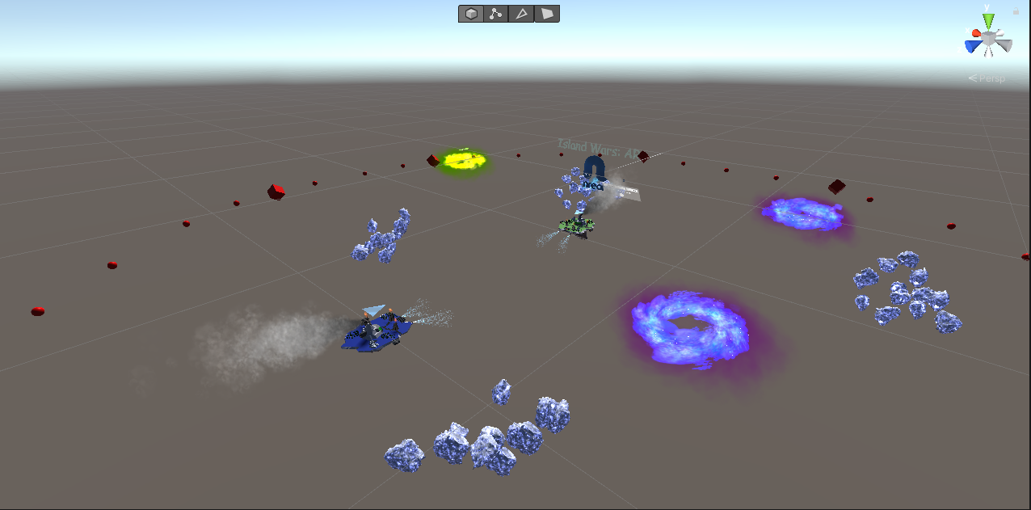

*Arena*

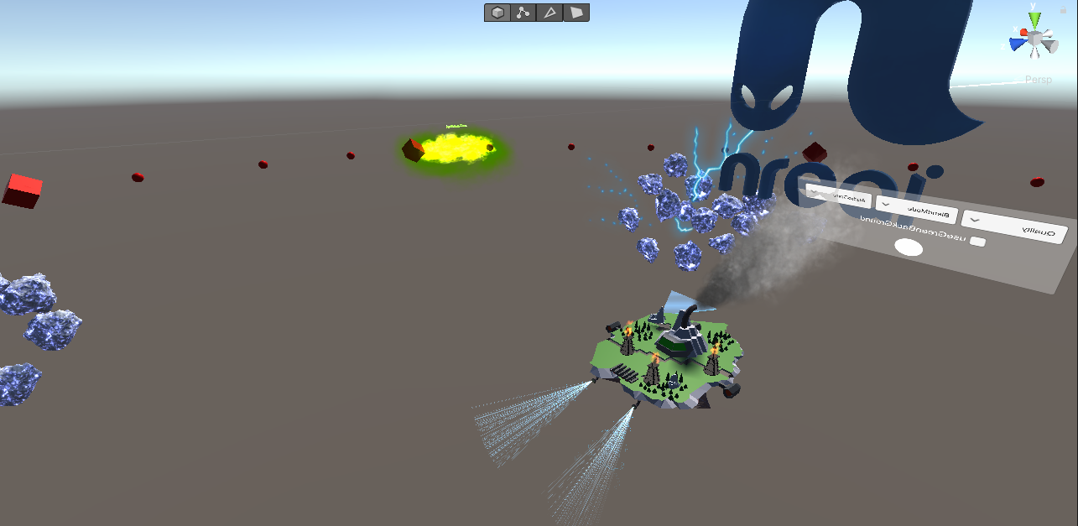

## In App Screenshots

Below are screenshots take while the application is running. As mentioned before, the video recording is okay on the hardware but was much better on the Magic Leap, which had the recording option right out of the box. For Nreal Light, the recordings had to be coded into the application.

*The Island close up – Player Bot*

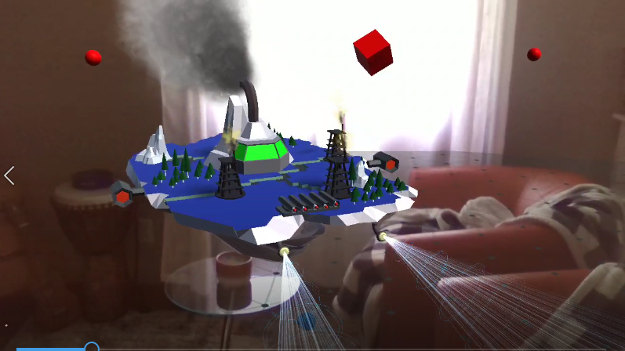

Player 1 – Close up

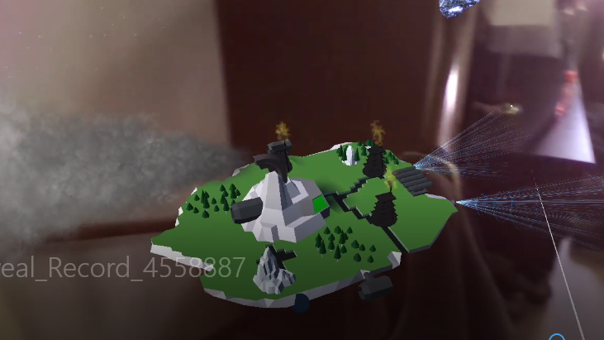

*Player 1 – On the move*

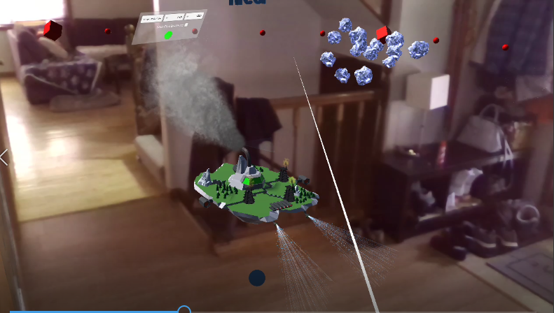

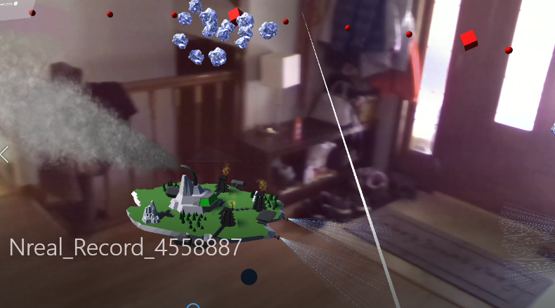

*Far shot with Island Wars logo.*

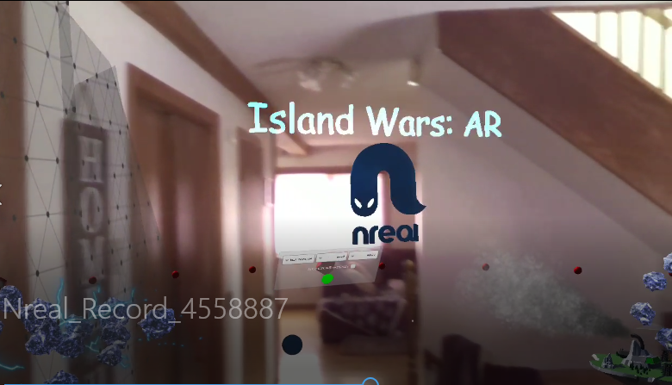

Far shot – Island near rocks

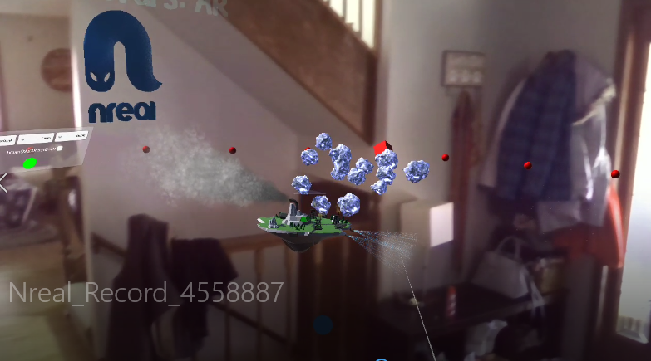

Close up - Environmental Hazard

